**GNEN LECTURE PROGRAM in FY 2017**

**by Japanese University Network for Global Nuclear Human Resource Development (JUNET-GNHRD)**

The Japanese University Network for Global Nuclear Human Resource Development (JUNET-GNHRD) will propose to provide following four lectures in FY2017 through telecommunication network (“distance learning”) of the Global Nuclear Education Network (GNEN) for the further development of expertise in the nuclear field.

JUNET-GNHRD was established in December 2010 under a cooperation of 18 universities for efficient and effective sharing of their educational resources and capabilities with close collaboration of the industry and relevant governmental agencies. The member universities of the JUNET-GNHRD are Hokkaido University, Hachinohe Institute of Technology, Ibaraki University, Nagaoka University of Technology, Shonan Institute of Technology, Tokai University, University of Yamanashi, Kanazawa University, University of Fukui, Nagoya University, Kyoto University, Osaka University, Kinki University, Okayama University, Kyushu University, Waseda University, Tokyo City University and Tokyo Institute of Technology.

**Lecture 1**

Title: Human-friendly Radiation Therapy –Boron Neutron Capture Therapy-

Date: October 30, 2017

Lecturer: Prof. Isao Murata (Osaka University)

**Lecture 2**

Title: Fundamentals of nuclear security

Date: November 13, 2017

Lecturer: Prof. Hiroshi Sagara (Tokyo Institute of Technology)

**Lecture 3**

Title: Introduction to Back-end of Nuclear Fuel Cycle

Date: December 15, 2017

Lecturer: Prof. Yohichi Enokida (Nagoya University)

**Lecture 4**

Title: Plutonium Issues

Date: March 12, 2018

Lecturer: Prof. Masaki Saito (Tokyo Institute of Technology)

Each Lecture time will be basically scheduled as following time frame;

|  |  |  |  |
| --- | --- | --- | --- |
|  | Thailand Time | Malaysian Time | Japan Time |
| **Opening Remarks:** | **9:00 - 9:05** | **10:00 -10:05** | **11:00 - 11:05** |
| **Lecture:** | **9:05 - 10:30** | **10:05 - 11:30** | **11:05 - 12:30** |
| **Q&A Session:** | **10:30 - 11:00** | **11:30 - 12:00** | **12:30 - 13:00** |

**Curriculum Vitae of Lectures**

**Prof. Dr. Isao Murata**

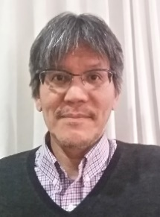Professor of Osaka University, Head of Division of Sustainable Energy and Environmental Engineering, Director of United Neutron Ltd.

Professor Murata worked for former JAERI from 1988-1994 as a researcher to develop Japanese High Temperature Engineering Test Reactor (HTTR). In the beginning of 1995 he moved to Osaka University. Since then, he was engaged in fusion neutronics studies on such as neutron cross section measurements, shielding experiments and so on and Monte Carlo transport theory of neutral particles. From 2001 to 2003, as a guest scientist he worked for Research Center Juelich (FZJ), Germany, to develop European Spallation Source (ESS). From 2004 he began to conduct BNCT studies with medical doctors to develop various radiation devices for BNCT and to establish an ABNS (accelerator based neutron source) based BNCT in Japan.

**Prof. Dr. Hiroshi Sagara**

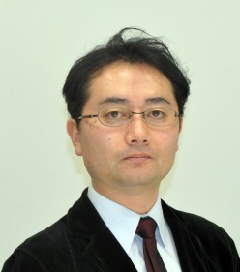Associate Professor, Doctor of Engineering,

Laboratory for Advanced Nuclear Energy, Institute of Innovative Nuclear Research, Tokyo Institute of Technology, Japan

Professor Sagara is involved in the research fields of nuclear reactor physics, advanced nuclear energy systems for transmutation of radioactive nuclear waste, and robust nuclear energy system designs against threats to safety, security and safeguards/non-proliferation. He has carriers at Tokyo Institute of Technology as well as at research institutes of Idaho National Laboratory. U.S.A., and Japan Atomic Energy Agency. He received Best Article Award, the 47th Atomic Energy Society of Japan Awards, 2015.

**Prof. Youichi Enokida, Dr. Eng**.

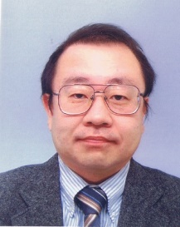Professor at Department of Applied Energy, Graduate School of Engineering, Nagoya University

Director of Management Facility for Nuclear Materials, Nagoya University

Professor Enokida has stayed and worked for education and academic researchers at the department of Nuclear Engineering in The University of Tokyo, Japan, Fuel Recycle Division in Oak Ridge National Laboratory, USA, The department of Chemistry in the University of Idaho, USA. He expertizes ‘Nuclear Chemical Engineering,’ from isotope separation to nuclear waste management as well as process systems engineering for nuclear fuel cycle. He is currently working as a member of Nuclear Fuel Safety Examination Committee in Nuclear regulation Authority, Japan.

**Prof. Dr. Masaki Saito**

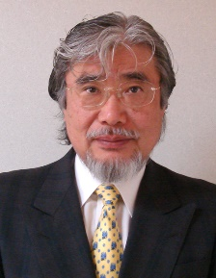Professor Emeritus and Institute Professor,

Director of Academy for Global Nuclear Safety and Security Agent, Doctor of Engineering

Tokyo Institute of Technology

**Education:**

1978 Doctor Course of Nuclear Engineering, Osaka University, Japan (Doctor of Engineering)

**Work Experience:**

1978-1981 School of Nuclear Engineering, Purdue University, Indiana, United States

1981-1992 Power Reactor and Nuclear Fuel Development Corporation, Japan

1989-1992 Department of Nuclear Engineering, Osaka University, Japan

1992-2008 Research Laboratory for Nuclear Reactor, Tokyo Institute of Technology, Japan

2008-2010 Head of Department of Nuclear Engineering, Tokyo institute of Technology

2011-present Director, Academy for Global Nuclear Safety and Security Agent, Tokyo Institute of Technology, Japan

**Awards:**

-Best Paper Award in Thermal-Hydraulic Division of American Nuclear Society in 1992.

-Honorable Diploma from Obninsk Institute for Nuclear Power Engineering, Russia in 2001.

-Diploma of Honor from Moscow Engineering Physics Institute, Russia in 2001.

-Award of Culture from Gobo-city, Wakayama prefecture, Japan in 2006

-Award for Eminent Achievements in Nuclear Science and Technology, Atomic Energy Society of Japan in 2014

-Nuclear Achievement Award, Atomic Energy Society of Japan in 2014

-Prizes for Science and Technology (Research Category), The Commendation for Science and Technology by the Minister of Education, Culture, Sports, Science and Technology in 2015